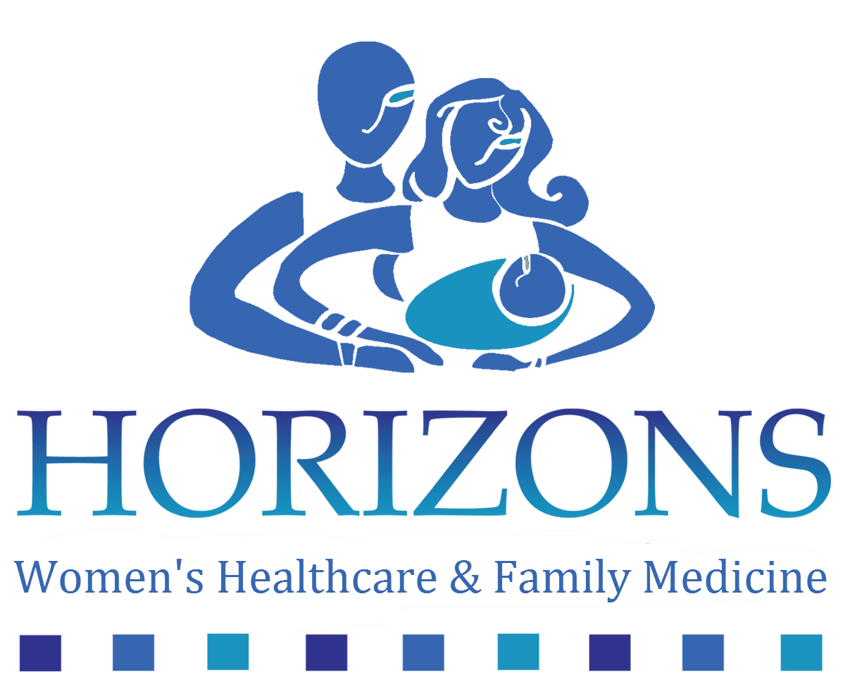

**Medical Assistant**

Human Resource Department

627 Edwin C. Moses Blvd

5th flr, Ste. M

Dayton, OH 45417

Email: hwhc@horizonswomens.com

Phone: (937) 228-4942

Area: Montgomery

Interviewing Manager(s): Charlotte Harris, hwhc@horizonswomens.com

This job reports to the Medical Assistant Manager and pays $10.50 - $14.00 per hour and no bonus. Relocation is not provided and travel is not required

Number of openings for this position: 1

Eligible for Over-Time: YES

Eligible of Shift Differential: NO

**Overview**

Come join a warm, friendly team of professionals that truly cares about their patients. If you have an interest in women's healthcare, pediatrics and family medicine and want to make a difference in the lives of others, please apply.

**Job Skills/Requirements**

The candidate MUST have experience in Family Practice OR OB/GYN. Must possess skill like vaccination administration, phlebotomy and should be proficiently trained to perform both

administrative and clinical tasks in the medical care environment.Pediatric experience preferred

**Minimum Education**

The Medical assistant should have an Associate of Applied Science degree from a CAAHEP-accredited college program and have successfully passed a national certification exam.

**Major Administrative Responsibilities:**

Greeting patients, scheduling appointments, scheduling surgeries, reporting to physicians and nurses,coordinating patient testing and referrals.

**Major Clinical Responsibilities:**

Coordination of Adult, Women, Obstetric and Pediatric patients, administer medications and immunizations, perform basic lab tests, phlebotomy skills and preparing patients in rooms to see physician with proper vitals and room set-up, procedure set-up.

**Major Skills Required:**

Excellent computer skills with a working knowledge of an EMR Microsoft Word and PDF files. Excellent customer service and communications skills, highly professional phone voice.

**Benefits:** Medical Insurance, Paid Vacation, Paid Sick Days, Paid Holidays

**Screening Requirements:**

Drug Screen, Criminal Background Check

**Follow-Up Contact Information:**

Human Resource Department

627 Edwin C. Moses Blvd

5th flr, Ste. M

Dayton, OH 45417

Email: hwhc@horizonswomens.com

Phone: (937) 228-4942